**Name**

Holiday Maze is a GUI text based game that utilizes JavaFx to display the user interface. It has been coded in Java using the Apache NetBeans IDE.

**Descriptiona**

The program’s user interface was designed using JavaFX Scene Builder 11.0.0 and is coded in the Apache NetBeans IDE 12.0 using Java with Maven. There are five fxml files located in the \src\main\resources\HolidayMaze folder. A description of the fxml files is listed below:

* **mainMenu.fxml**
  + This fxml file is the parent for the other fxml files. It has a vBox that is populated with the other fxml files when the Thanksgiving/Blackfriday, Halloween, and Christmas buttons on the left of the screen are pressed.
* **thanksgivingBlackFriday.fxml**
  + Has five radiobuttons that direct you in the maze.
* **recipientInfo.fxml**
  + Has three textfields and a button. The user enters their name, age, and gender into the appropriate text fields and presses a submit button. Afterwards, a maze is displayed based on the user’s selection.
* **halloween.fxml**
  + Has five radiobuttons that direct you in the maze.
* **christmas.fxml**
  + Has five radiobuttons that direct you in the maze.

In addition, there are two buttons located on the main fxml file that when pressed either exit the program or open the README.docx file.

**Visuals**

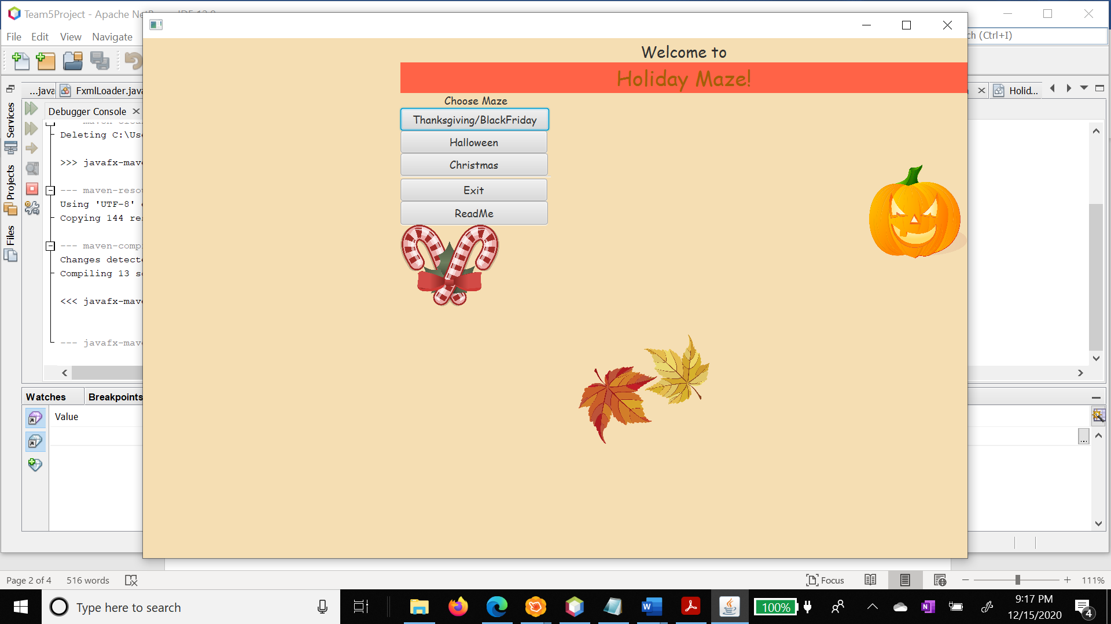

*main.fxml* *1*

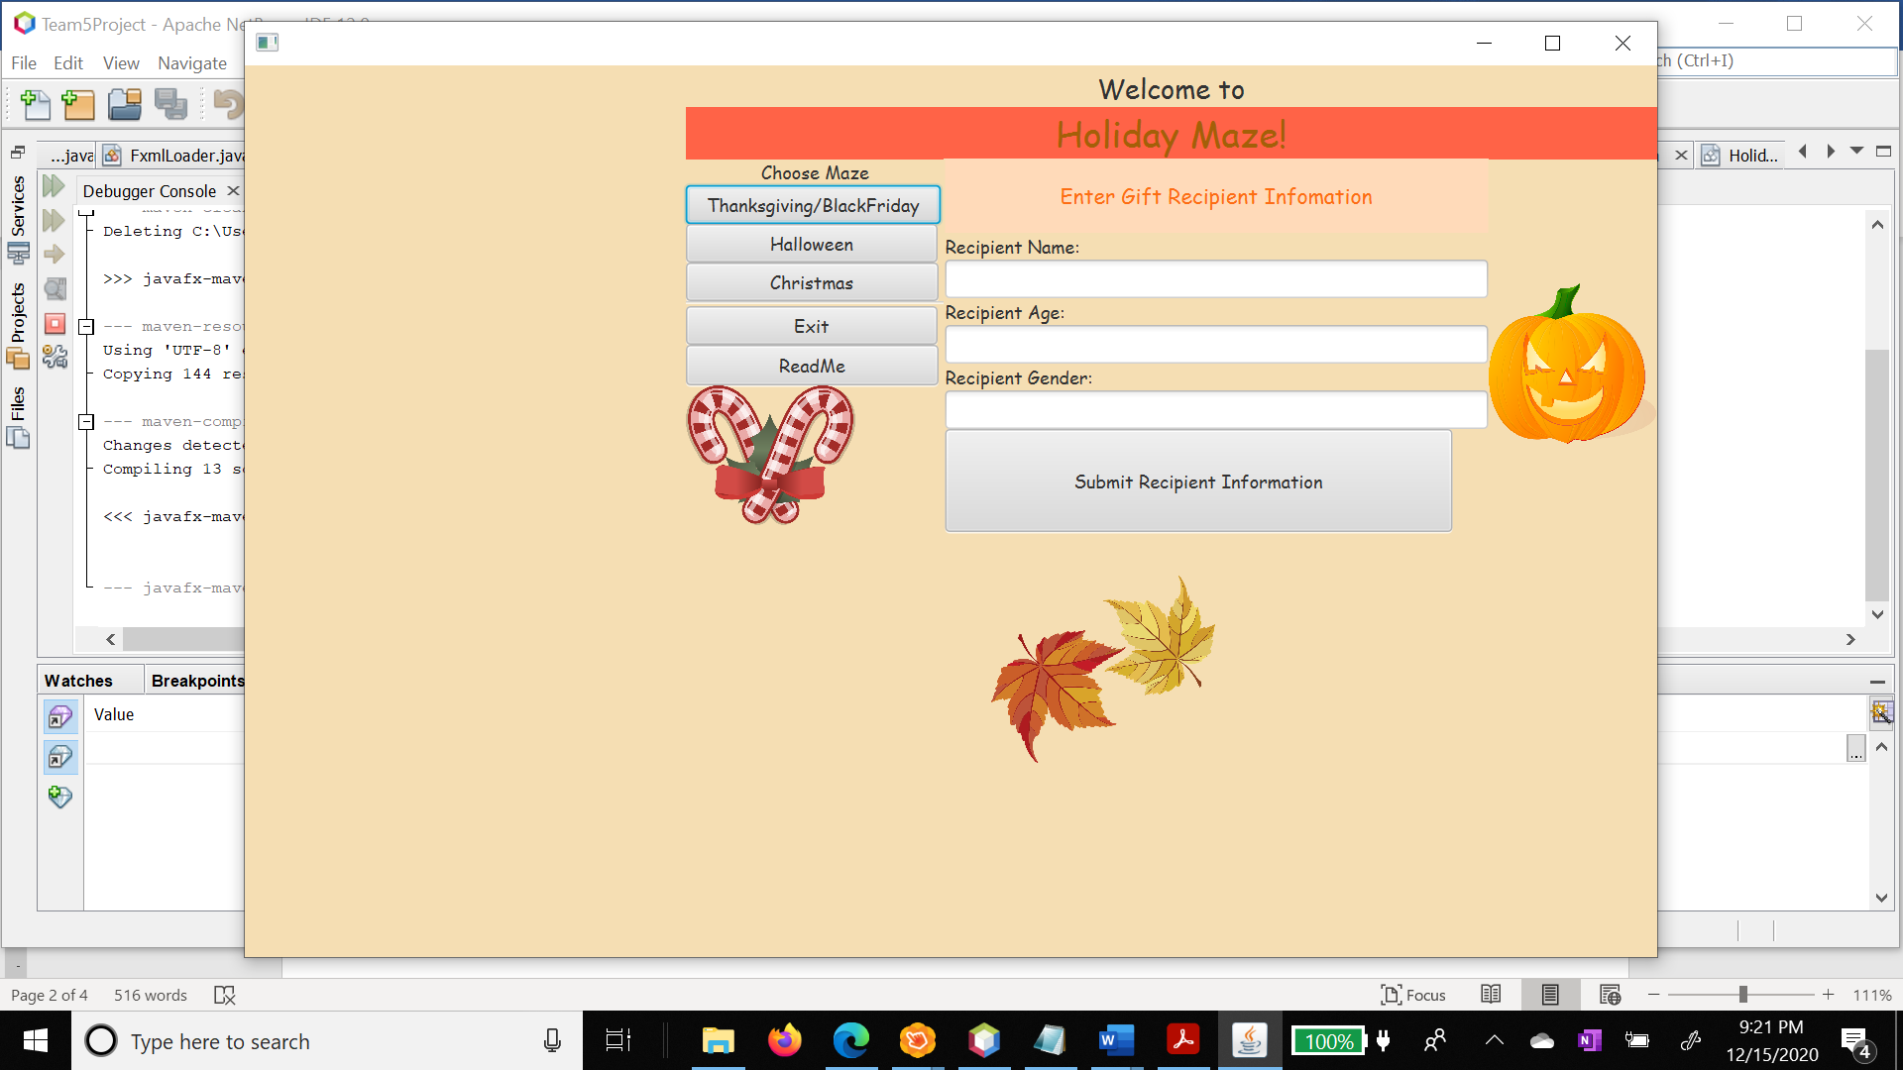

*recipientInfo.fxml 2*

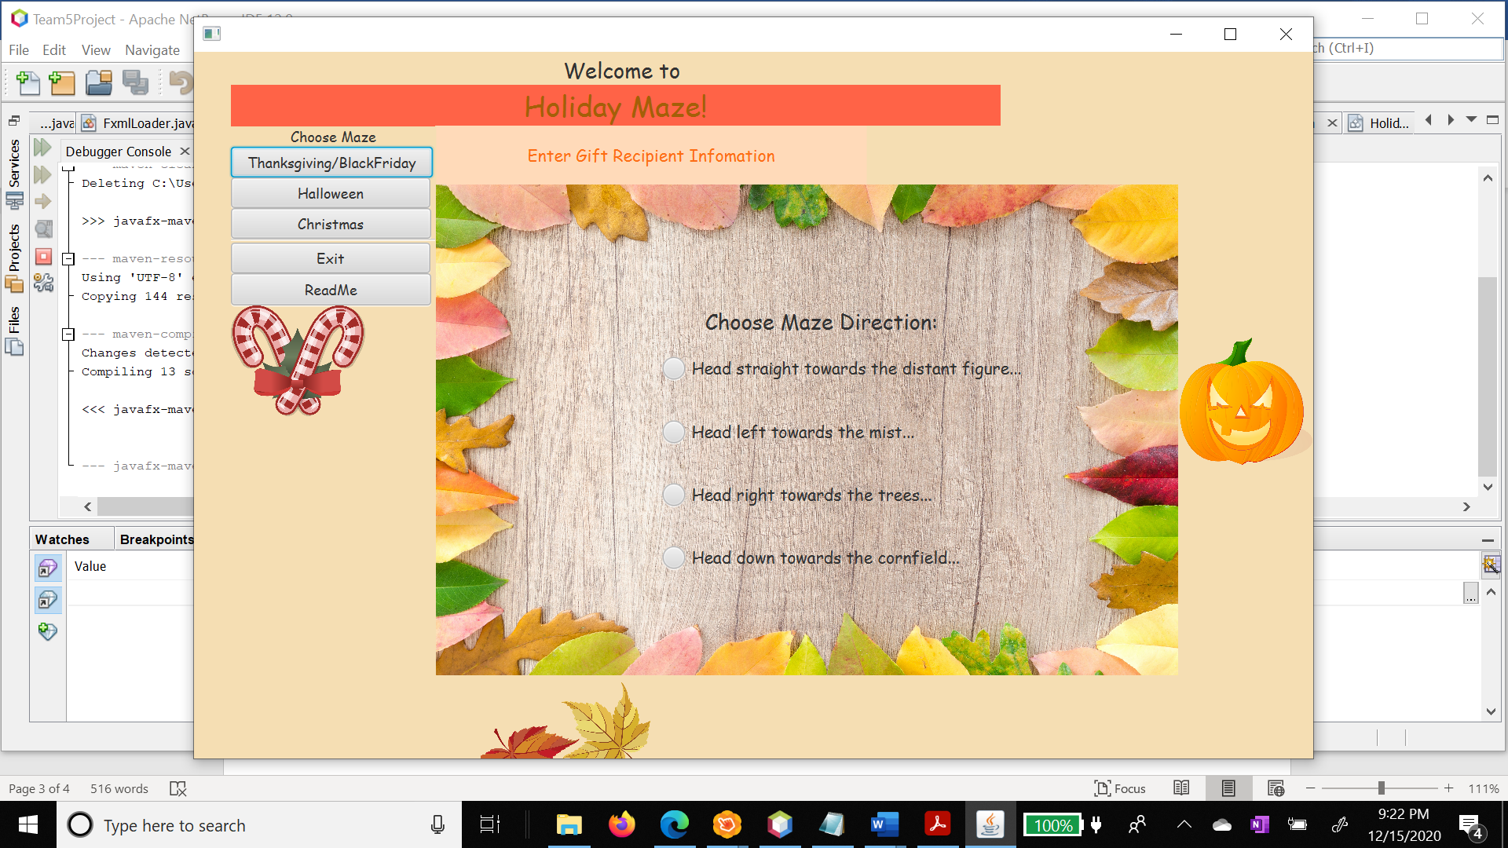

thanksgivingBlackFriday.fxml 3

**Usage**

The program is called Team5Project. The hierarchy of the program is located below: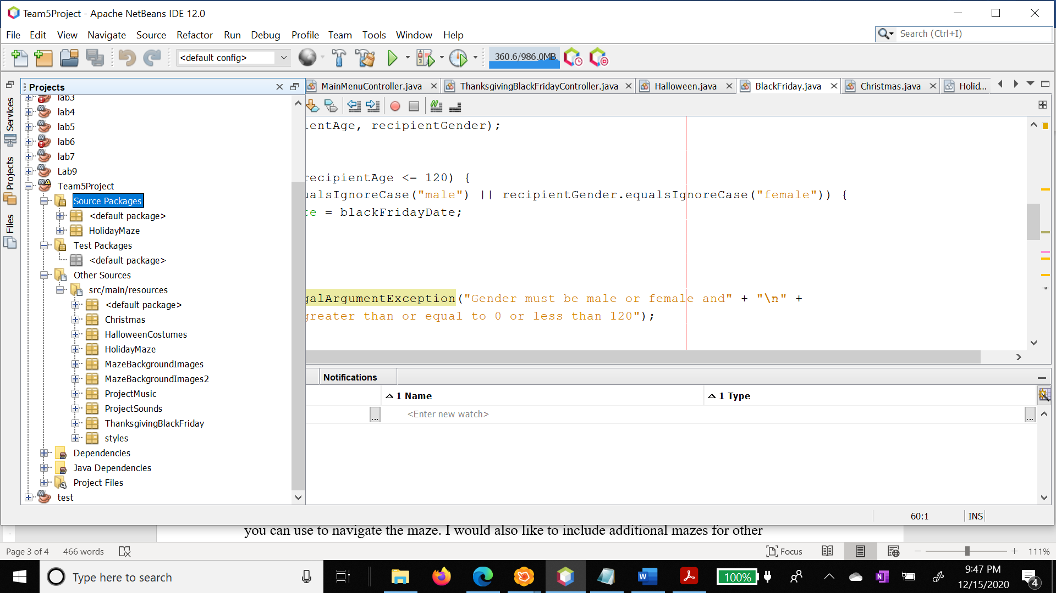

Program Structure 4

The source files and their purpose are:

**module-info.java:** module establishes limits to what the components of the program can access within it

**App.java:** Setsthe scene, stage, root, and parent xml file

**FxmlLoader.**java: Loads the appropriate xml file into the parent based on the maze chosen

**MainMenuController.java:** Plays Intro.wav music located in \src\main\resources\ProjectMusic folder; Also loads user selected maze into the parent fxml, closes program, opens ReadMe

**Global.java:** Class is used to make text data retrieved from RecipientInfoController.java available to other classes

**Holiday.java:** Abstract class used as template for BlackFriday, Christmas, and Halloween classes

**ThanksgivingBlackFridayController.java:** Contains event handling methods for direction

**radio buttons.BlackFriday.java:** Class inherits from superclass Holiday.java; Loads images from\src\main\resources\ProjectMusic folder into blackFridayList ArrayList

**ChristmasController.java:** Contains event handling methods for direction

**Christmas.java:** Class inherits from superclass Holiday.java; Loads images from\src\main\resources\ProjectMusic folder into christmasList ArrayList

**HalloweenController.java:**

**Halloween.java:** Class inherits from superclass Holiday.java; Loads images from\src\main\resources\ProjectMusic folder into halloweenList ArrayList

**RecipientInfoController.java:** Set global variables to contents of recipient info text fields and loads appropriate fxml file into parent based on user selection

**Support**

For help with Holiday Maze I can be reached at joylove@iu.edu.

**Roadmap**

For future Holiday Maze releases I would like to have a graphic maze with an animated character you can use to navigate the maze. I would also like to include additional mazes for other holidays.

**Authors and acknowledgment**

Holiday Maze is a solo project for my [IU](https://www.iusb.edu/) Programming 2 Java class. The only author is me, Joy Love 😊

**Project status**

Even though my class officially ended December 15, 2020, I plan to continue with the project. There is additional functionality I would like to add which includes:

* Fix noted program logic errors:
* Images from the \src\main\resources should load into an arraylist populated from images retrieved from the BlackFriday.java, Halloween.java, and Christmas.java class method getImageList(). Subsequent images based on recipient age and gender should be displayed as icons in JOptionPane after selecting a direction radio button.
* Maze scenes should not display if:
  + Any recipient text fields are left blank
  + Recipient age less than 0 or greater than 120
  + Recipient gender is not male or female
* Ability to save gift recipient information from each instantiated class object to create a gift list text file.
* Change of music and added sound effects that are unique to each maze by utilizing the package java.scene.media.Media instead of packagejava.scene.media.AudioClip to play music. Audio sounds will use the class AudioClip. These media files can be found in \src\main\resources in the ProjectSounds and ProjectMusic folders. All music and sounds are royalty free and are available from [Sound Bible](http://soundbible.com/) and [Free Music Archive](https://freemusicarchive.org/search).
* Adjustments to the user interface using JavaFX Scene Builder 11.0.0. Additional buttons to pause the music for the main menu and each maze. Also, adjustments to the scene and stage size.